
DEPT. OF COMPUTER
SCIENCE AND APPLICATIONS

PANJAB UNIVERSITY,
CHANDIGARH

ATM System using Python

Submitted To: Submitted By:
Dr. Rohini Sharma Sakshi Sharma
MSc CS-1
Roll no: -18
Introduction
ATMs allow one to perform multiple banking functions such as withdrawal of cash, making balance enquiries, transferring money from one account to another, paying insurance premium, making small loans and payment of bills. Issue of noncash items like coupons and movie tickets, and gold coins is also possible through ATMs. This vast array of activities is executed by using a plastic, magnetic-stripe card and personal identification number issued by the financial institutions. There was a common feeling that many will go for Internet banking and the use of ATMs will be irrelevant. However, ATM channels are now becoming critically important as a self-service technology channel. Banks are adding more and more functionalities through open standard technology. There is a fast societal shift towards ATM as a self-service personalized delivery channel foremost customer.

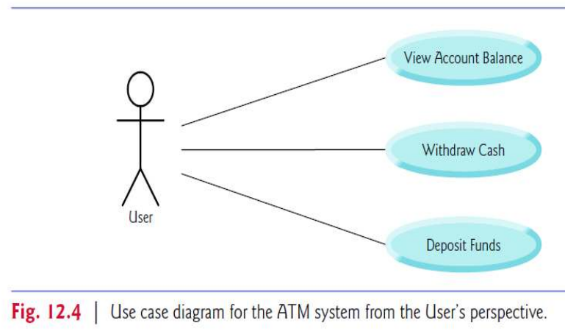

Objective

The main purpose of the ATM division and information service is to provide the customers financial flexibility, worldwide acceptance and round the clock convenience. Bank issues only VISA Credit Cards, the renowned Credit Card brand. Cardholders can purchase goods/services up to the credit limit and can reuse the credit facility upon repayment. Credit Card is a safer substitute to cash and is the major mode of payment worldwide. Standard Chartered Bank is the first to introduce the TAKE CREDIT CARD. The card is issued basically to
a person’s name and the specific person can use the card in anywhere in Bangladesh. The business activity of Premier Bank Credit Card section is to keep the records of all sales and customers’ requests, the information of cardholders and reports them to necessary documents

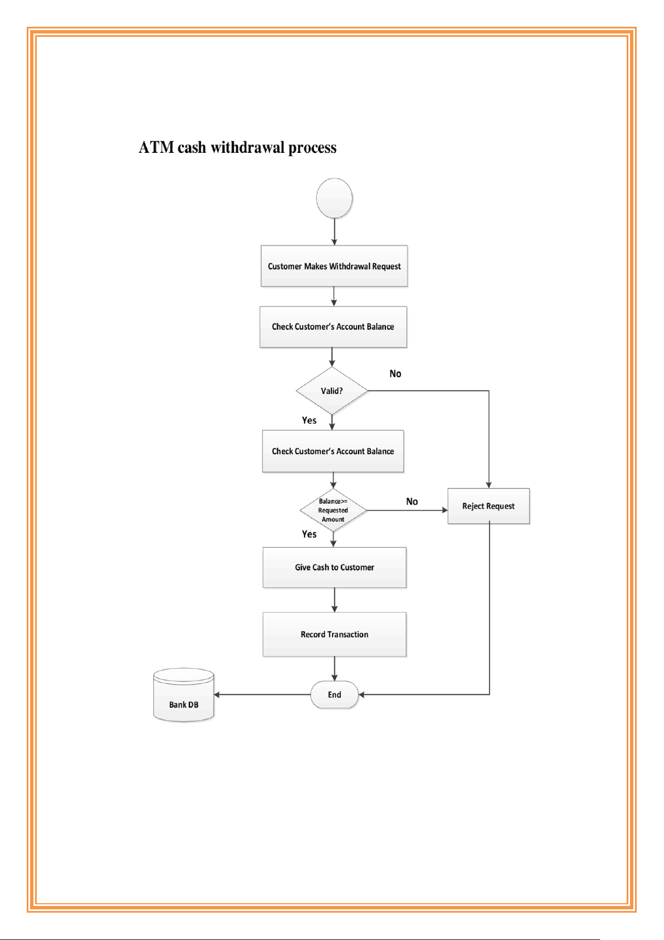Features:
- User Authentication: Users are required to enter a valid PIN to access their accounts, ensuring security and privacy.
- Balance Inquiry: Users can check their account balance to view the current available funds.
- Cash Withdrawal: Users can withdraw money from their accounts, and the system updates the balance accordingly.
- Cash Deposit: Users can deposit money into their accounts by providing the necessary details.
- Logout: After completing transactions, users can securely log out of their accounts to prevent unauthorized access.

Software Requirements:
- Platform Used: Python
- Type of Application: Desktop-based application
- Programming Language: Python
- IDE Tool: Python Editor

Advantages
- Convenience to Customers
- Offer 24×7 Service
- Reduce Bank Workload
- Access from anywhere
- Stable
- Accuracy
- Comfort

Disadvantages
- Charges Fees
- Limitation of cash withdrawal
- Small target
- Sometimes False acceptances and rejections.
- Possibility of frauds

CODE:
import getpass
import string
import os

# creating a lists of users, their PINs and bank statements
users = ['user1', 'user2', 'user3']
pins = ['1010', '2020', '3030']
amounts = [25000, 82000, 43000]
count = 0
print("****************************************************************************")
print("* *")
print("* WELCOME TO ATM SYSTEM *")
print("* *")
print("****************************************************************************")
# while loop checks existence of the entered username
while True:
user = input('\n ENTER USER NAME: ')
user = user.lower()
if user in users:
if user == users[0]:
n = 0
elif user == users[1]:
n = 1
else:
n = 2
break
else:
print('****************')
print('INVALID USERNAME')
print('****************')

# comparing pin
while count < 3:
print('******************')
pin = input('PLEASE ENTER PIN: ')
print('******************')
if pin.isdigit():
if user == 'user1':
if pin == pins[0]:
break
else:
count += 1
print('***********')
print('INVALID PIN')
print('***********')
print()

if user == 'user2':
if pin == pins[1]:
break
else:
count += 1
print('***********')
print('INVALID PIN')
print('***********')
print()

if user == 'user3':
if pin == pins[2]:
break
else:
count += 1

print('***********')
print('INVALID PIN')
print('***********')

print()
else:

print('************************')
print('PIN CONSISTS OF 4 DIGITS')
print('************************')

count += 1

# in case of a valid pin- continuing, or exiting
if count == 3:

print('***********************************')
print('3 UNSUCCESFUL PIN ATTEMPTS, EXITING')
print('!!!!!YOUR CARD HAS BEEN LOCKED!!!')
print('*************************')
exit()

print('*************************')
print('LOGIN SUCCESFUL!')
print('*************************')

print()

print('**************************')
print(str.capitalize(users[n]), 'welcome to ATM')
print('**************************')
print('----------ATM SYSTEM-----------')
# Main menu
while True:
#os.system('clear')

print('*******************************')
response = input('SELECT FROM FOLLOWING OPTIONS: \nBalance__(B) \nWithdraw___(W) \nDeposit__(D) \nChange PIN_(P) \nQuit_______(Q) \nType The Letter Of Your Choices: ').lower()
print('*******************************')

valid_responses = ['b', 'w', 'd', 'p', 'q']
response = response.lower()
if response == 'b':

print('*********************************************')
print(str.capitalize(users[n]), 'YOU HAVE ', amounts[n],'RUPEES IN YOUR ACCOUNT.')
print('*********************************************')

elif response == 'w':

print('*********************************************')
cash_out = int(input('ENTER AMOUNT YOU WOULD LIKE TO WITHDRAW: '))
print('*********************************************')

if cash_out%500 != 0:

print('******************************************************')
print('PLEASE ENTER AMOUNT IN NOTES OF 500')
print('******************************************************')

elif cash_out > amounts[n]:

print('*****************************')
print('YOU HAVE INSUFFICIENT BALANCE')
print('*****************************')

else:
amounts[n] = amounts[n] - cash_out

print('***********************************')
print('YOUR NEW BALANCE IS: ', amounts[n], 'RUPEES')
print('***********************************')

elif response == 'd':
print()

print('*********************************************')
cash_in = int(input('ENTER AMOUNT YOU WANT TO DEPOSIT: '))
print('*********************************************')

print()
amounts[n] = amounts[n] + cash_in

print('****************************************')
print('YOUR NEW BALANCE IS: ', amounts[n], 'RUPEES')
print('****************************************')

elif response == 'p':

print('*****************************')
new_pin = str(getpass.getpass('ENTER A NEW PIN: '))
print('*****************************')

if new_pin.isdigit() and new_pin != pins[n] and len(new_pin) == 4:

print('******************')
new_ppin = str(getpass.getpass('CONFIRM NEW PIN: '))
print('*******************')

if new_ppin != new_pin:

print('************')
print('PIN MISMATCH')
print('************')

else:
pins[n] = new_pin
print('NEW PIN SAVED')
else:

print('*************************************')
print(' NEW PIN MUST CONSIST OF 4 DIGITS \nAND MUST BE DIFFERENT TO PREVIOUS PIN')
print('*************************************')

elif response == 'q':
exit()
else:

print('******************')
print('RESPONSE NOT VALID')
print('******************')

OUTPUT:

Conclusion

ATMs can now perform better jobs as the experience is personalized. Banks are slowly changing their software on a regular basis and have uniform behavior across their entire network. This improves customer service, reduces the cost for the banks and increases efficiency. As per reports of Retail Banking Research (2010), emergence of multivendor and multichannel ATM has made a paradigm shift towards central monitoring from head office, consistent and uniform services, quick response, convenience maintenance and simplified ATM purchase.

